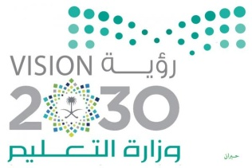
المملكة العربية السعودية
وزارة التعليم
الإدارة العامة للتعليم بتبوك
الابتدائية السادسة بالوجه

In 6th of october2019 at 6th elementary school
We did a presentation talked about the space
In 7th of oct, the student draw about the space
In Thursday we made a corner about "space" and school broadcast.

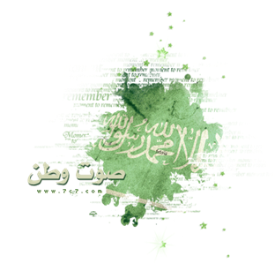

Prince Sultan bin Salman is the first Muslim Arab astronaut
His Royal Highness Prince Sultan bin Salman bin Abdulaziz Al Saud is the first Muslim Arab astronaut. He was born in Saudi Arabia on June 27, 1956, and is the second son of King Salman bin Abdul Aziz. Al Saud
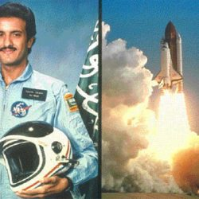

Qualifications
Prince Sultan bin Salman received many qualifications and degrees, including
: [5] He holds a license in the field of civil aviation, Federal Aviation Authority of the United States of America. Flight Specialist in Flight as an astronaut in 1985. He holds a master's degree (tribal transformation and national construction in the Saudi experience) from Syracuse University in the United States of America in the field of social and political sciences in 1999. Holds a flight license BBJ / B737 in 2012

Practical experiences

Prince Sultan bin Salman has diverse experience in many professional and functionl
fields, most importantly
I was promoted to the Ministry of Information in the Department of International Communications in1982
Director of the Saudi Olympic Committee in Los Angeles during the Olympic Games in 1984.
A member of the International Astronautics Team and a representative of the Arab Satellite Telecommunications Organization (ARAB SAT) in 1985.

Commander in the Air Force of the Kingdom of Saudi Arabia at the rank of presenter in 1985

Chairman of the Science Oasis Project Committee to be established in Riyadh, Saudi Arabia
President of the Saudi Charity Association for Children with Disabilities during 1989, re-elected in 1992 and Chairman of the Board of Trustees of Prince Salman Center for Disabled People.
Honorary President of the Saudi Computer Society in 1991.
President of the Saudi Society of Architecture in 1993
